Brown Marmorated Stick Bug (BMSB) 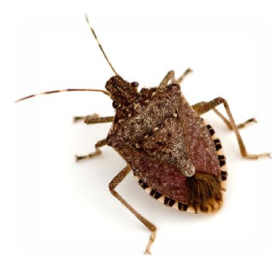
2022 - 2023 Season

The Department of Agriculture, Fisheries & Forestry (DAFF) has finalised the seasonal measures for the 2022-23 BMSB risk season. The measures remain consistent with the 2021-22 BMSB risk season for the 2022–23 season for certain goods manufactured in, or shipped from target risk countries as sea cargo between 1st September 2022 and 30th April 2023 (inclusive).

Note: The shipped on-board date, as indicated on the Ocean Bill of lading, is the date used to determine when goods have been shipped. “Gate in” dates and times will not be accepted to determine when goods are shipped.
Goods must be treated for BMSB if exported between 1 September 2022 and 30 April 2023 (inclusive).

With the change of Post BMSB fumigation inspections moving from Seals Intact-Supervised Unpacks to “Inspect (unpack) Inspections instead of Secure Seals intact inspections at Approved Arrangements” we should hopefully see some relief from last season in the turnaround time of inspections.
The final seasonal measures are available on the BMSB webpage

Target Risk Countries
The following countries have been categorised as target risk. Any target high risk or target risk goods which are manufactured in, or shipped from these countries will be subject to BMSB seasonal measures:
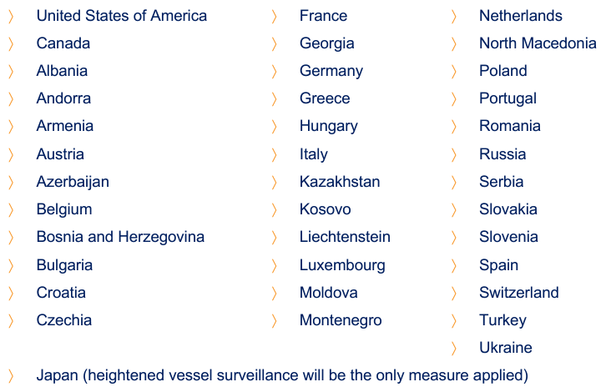

This upcoming season, China and The United Kingdom have been categorized as emerging risk countries, with set periods of random onshore inspections for both Countries (China being 1st September to 31st December and UK being 1st December to 30th April).

Target High Risk Goods
Goods that fall within the tariff classifications as advised per the below DAFF link, have been categorised as target high risk goods, and will require mandatory treatment for BMSB risk.
https://www.agriculture.gov.au/biosecurity-trade/import/before/brown-marmorated-stink-bugs#collapsible_inner_link_target-high-risk

44 - Wood and articles of wood | 74 - Copper and articles thereof | 83 - Miscellaneous articles of base metals
45 - Cork and articles of cork | 75 - Nickel and articles thereof | 84 - Nuclear reactors, boilers, machinery and mechanical appliances; parts thereof
57 - Carpets and other textile floor coverings | 76 - Aluminium and articles thereof | 85 - Electrical machinery and equipment and parts thereof
68 - Articles of stone, plaster, cement, asbestos, mica or similar materials | 78 - Lead and articles thereof | 86 - Railway or tramway locomotives, rolling-stock and parts thereof
69 - Ceramic products | 79 - Zinc and articles thereof | 87 - Vehicles other than railway or tramway rolling-stock, and parts and accessories thereof
70 – Glass and glass ware | 80 - Tin and articles thereof | 88 - Aircraft, spacecraft, and parts thereof
72 - Iron and steel | 81 - Other base metals; cermet’s | 89 - Ships, boats and floating structures
73 - Articles of iron or steel | 82 - Tools, implements, cutlery, spoons and forks, of base metal
** Chapters 94 and 95 will be subject to random inspections for emerging risk countries

Target Risk Goods
Goods that fall within the tariff classifications as advised per the below DAFF link, have been categorised as target risk goods, and will not require mandatory treatment. Target risk goods will however be subject to increased onshore intervention through random inspection
https://www.agriculture.gov.au/biosecurity-trade/import/before/brown-marmorated-stink-bugs#collapsible_inner_link_target-risk

** For all other goods that are not categorised as “Target High Risk” and “Target Risk Goods”, BMSB seasonal measures do not apply. However, these goods may be subject to the measures if they are part of a container or consignment that contains Target High Risk or Target Risk Goods.

New, Unused and not Field Tested (NUFT) goods

Certain goods that can meet all the following criteria will not be subject to mandatory BMSB treatment:
- Manufactured on or after 1 December (manufacture must start from 1 December).
- Goods classified under the following tariff chapters only will be allowed under this concession: 82, 84, 85, 86, 87, 88 and 89.
- Evidence must be provided in the form of a BMSB NUFT (new, unused and not field tested) manufacturers declaration that the goods are manufactured on or after 1 December.
BMSB NUFT Declaration Template can be found here: https://www.agriculture.gov.au/sites/default/files/documents/bmsb-nuft-declaration.pdf

Treatment Requirements

Mandatory Offshore Treatment

• LCL consignments and FAK containers

Offshore treatment of target high risk goods shipped in sealed six sided containers, as LCL (less than container load) and FAK consolidated (freight of all kinds) is being proposed again under the 2022–23 season, with potential option for treatment on arrival prior to deconsolidation.
S.A.L. Global Logistics will be able to arrange the Treatment/Fumigation through our origin offices for all LCL cargo from the “Target Risk Countries” to comply with the required measures.

• Break bulk consignments

Mandatory offshore treatment of target high risk goods shipped as break bulk cargo including goods shipped in open top containers or on flat rack containers will continue to be required.
Onshore treatment is not permitted.
Break bulk includes those goods shipped on flat racks and in open top containers.
Untreated breakbulk will be denied discharge and be directed for export on arrival.

Mandatory Offshore or Onshore Treatment

• FCL consignments

Full Container Loads (FCL) with Target High Risk Goods shipped in sealed six hard sided containers can continue to be treated offshore or onshore at the container level. Deconsolidation or removal of goods will not be permitted before treatment. No exemptions for deconsolidation or segregation on arrival will be considered. Consideration must be given to ensure containers are packed in a manner that will enable effective onshore treatment where required, to avoid possible export of the container/s.
Unless directed, or requested, FCL containers from “Target Risk Countries” with “Target High Risk Goods” will undergo fumigation/treatment upon arrival at destination in Australia, as arranged by S.A.L. Global Logistics.
The main reason for managing treatment onshore vs offshore, is to avoid any double-costs where offshore treatment has been deemed unsatisfactory, or treatment providers delisted whilst goods are in transit, as experienced over previous seasons.

• Treatment Options The approved treatment options for goods requiring mandatory treatment are:
- Heat Treatment
- Methyl Bromide fumigation
- Sulfuryl Fluoride fumigation
For information on approved treatment rates, please visit https://www.agriculture.gov.au/biosecurity-trade/import/before/brown-marmorated-stink-bugs#treatment-types-and-rates-for-bmsb

Safeguarding Arrangements Scheme

The Safeguarding Arrangements Scheme offers an alternative clearance pathway for Brown Marmorated Stink Bug (BMSB) targeted goods, shipped in hard six-sided containers from risk countries during the BMSB risk season, 1 September 2022 to 30 April 2023.
The scheme offers importers the opportunity to demonstrate that processes in their manufacturing supply chain can effectively prevent their goods from being exposed and contaminated with BMSB and other exotic pests.
These approved alternative biosecurity controls remove the requirement of a mandatory BMSB treatment on arrival, by ensuring the goods are BMSB free prior to export to Australia.

Safeguarding Arrangements are only available to participants that meet the following eligibility criteria:
• Hold a valid Australian Business Number
• Goods must be transported in a hard six-sided shipping container
• Goods must be stored indoors between manufacture and export to Australia
• Processes and mitigation actions are in place (and can be demonstrated) throughout the
supply chain to protect the goods from exposure to BMSB, exotic pests and other biosecurity risks
• Contingency actions are in place (and can be demonstrated) in case BMSB is detected at any point in the supply chain
• If approved, all supply chain staff must complete the department’s online Hitchhiker awareness training and understand their obligations under the safeguarding agreement.
• Provide at least one supply chain compliance audit which meets your department approved supply chain plan for each manufacturing and indoor storage site, within 60 days of receiving formal approval for the current season. Applications from qualifying stakeholders should be lodged with DAFF.

Further information can be found at https://www.agriculture.gov.au/biosecurity-trade/import/before/brown-marmorated-stink-bugs/safeguarding

Further Information
For full details on the 2022–23 BMSB seasonal measures and for information visit the DAFF website: www.agriculture.gov.au/bmsb.
Please do not hesitate to contact us for any additional information as required –
e-mail: cs@salglobal.com.au or TEL: 1300 814 743

